DBMS - Mini Project

RECORD LABEL DATABASE

Submitted By:

Name:VINESH S

SRN:PES1UG20CS505

V Semester Section I

# Short Description and Scope of the Project:

This database application aims on maintaining the records of one of the most fundamental foundations of today’s music industry, the record labels. A record label provides support to various artist by helping them distribute their music, market it, give them a bigger audience by signing them under themselves. There are various nuances in making a record such as composing, producing mixing and mastering to deliver a final product. This final product has to be distributed in forms of streams and physical vinyl records by distributors. This application is a sample of such a database in action.

# ER Diagram

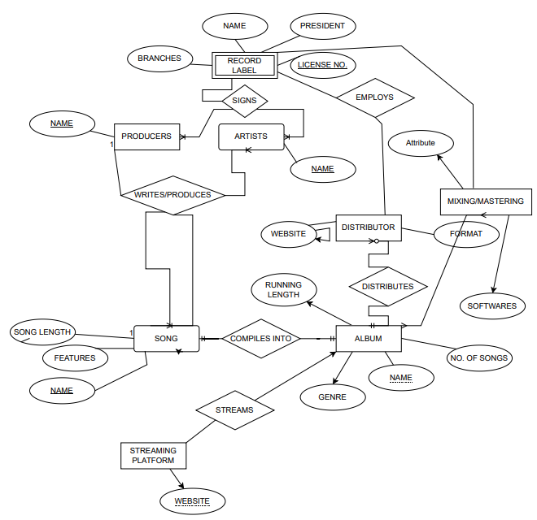

# Relational Schema

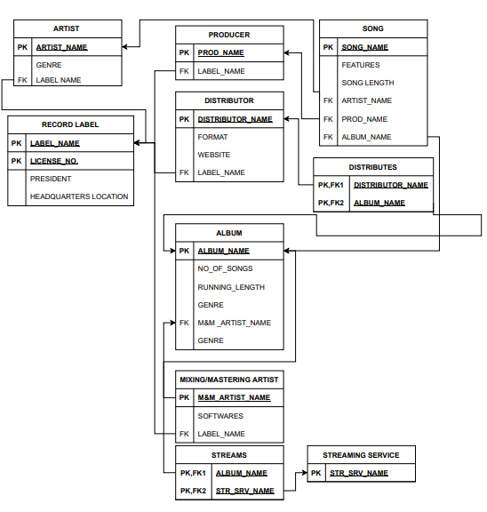

# DDL statements - Building the database

CREATE TABLE `dbms_project`.`artist` (

`Artist_name` CHAR NOT NULL,

`Genre` VARCHAR(45) NULL,

PRIMARY KEY (`Artist_name`))

ALTER TABLE `dbms_project`.`artist`

ADD COLUMN `label_name` VARCHAR(45) NULL AFTER `Genre`;

CREATE TABLE `dbms_project`.`record_label` (

`Label_name` CHAR NULL,

`license_no` INT NOT NULL,

`President` VARCHAR(45) NULL,

`Headquarters/location` VARCHAR(45) NULL,

PRIMARY KEY (`Label_name`, `license_no`));

ALTER TABLE `dbms_project`.`record_label`

CHANGE COLUMN `Label_name` `Label_name` VARCHAR(45) NOT NULL ;

CREATE TABLE `dbms_project`.`producer` (

`prod_name` VARCHAR(45) NULL,

`label_name` VARCHAR(45) NULL,

PRIMARY KEY (`prod_name`));

CREATE TABLE `dbms_project`.`song` (

`song_name` VARCHAR(45) NULL,

`feature` VARCHAR(45) NULL,

`song_length` INT NULL,

`artist_name` VARCHAR(45) NULL,

`prod_name` VARCHAR(45) NULL,

PRIMARY KEY (`song_name`));

ALTER TABLE `dbms_project`.`song`

ADD COLUMN `album_name` VARCHAR(45) NULL AFTER `prod_name`;

CREATE TABLE `dbms_project`.`album` (

`album_name` VARCHAR(45) NULL,

`no_of_songs` INT NULL,

`running_length` INT NULL,

`album_genre` VARCHAR(45) NULL,

`m&m_artist_name` VARCHAR(45) NULL,

PRIMARY KEY (`album_name`));

CREATE TABLE `dbms_project`.`distributor` (

`distributor_name` VARCHAR(45) NOT NULL,

`format` VARCHAR(45) NULL,

`website` VARCHAR(45) NULL,

`label_name` VARCHAR(45) NULL,

PRIMARY KEY (`distributor_name`));

CREATE TABLE `dbms_project`.`mixing&mastering_artist` (

`m&m_artist_name` VARCHAR(45) NOT NULL,

`softwares` VARCHAR(45) NULL,

`label_name` VARCHAR(45) NULL,

PRIMARY KEY (`m&m_artist_name`));

CREATE TABLE `dbms_project`.`streaming_service` (

`str_srv_name` VARCHAR(45) NOT NULL,

PRIMARY KEY (`str_srv_name`));

CREATE TABLE `dbms_project`.`distributes` (

`distributor_name` VARCHAR(45) NOT NULL,

`album_name` VARCHAR(45) NULL);

CREATE TABLE `dbms_project`.`streams` (

`album_name` VARCHAR(45) NOT NULL,

`str_srv_name` VARCHAR(45) NOT NULL,

PRIMARY KEY (`album_name`, `str_srv_name`));

# POPULATING TABLES:

INSERT INTO `dbms_project`.`album` (`album_name`, `no_of_songs`, `running_length`, `album_genre`, `m&m_artist_name`) VALUES ('malibu', '12', '56', 'r&b', 'sam');

INSERT INTO `dbms_project`.`album` (`album_name`, `no_of_songs`, `running_length`, `album_genre`, `m&m_artist_name`) VALUES ('freenats', '13', '106', 'r&b', 'bill');

INSERT INTO `dbms_project`.`album` (`album_name`, `no_of_songs`, `running_length`, `album_genre`, `m&m_artist_name`) VALUES ('innebloom', '7', '34', 'electronic', 'nick');

INSERT INTO `dbms_project`.`album` (`album_name`, `no_of_songs`, `running_length`, `album_genre`, `m&m_artist_name`) VALUES ('oasis', '32', '143', 'rock', 'gur');

INSERT INTO `dbms_project`.`album` (`album_name`, `no_of_songs`, `running_length`, `album_genre`, `m&m_artist_name`) VALUES ('ventura ', '10', '45', 'r&b', 'sam');

INSERT INTO `dbms_project`.`album` (`album_name`, `no_of_songs`, `running_length`, `album_genre`, `m&m_artist_name`) VALUES ('compton', '20', '67', 'hip-hop', 'dre');

INSERT INTO `dbms_project`.`album` (`album_name`, `no_of_songs`, `running_length`, `album_genre`, `m&m_artist_name`) VALUES ('detox', '11', '55', 'hip-hop', 'dre');

INSERT INTO `dbms_project`.`song` (`song_name`, `feature`, `song_length`, `artist_name`) VALUES ('bam', 'gunn', '346', 'paak');

INSERT INTO `dbms_project`.`song` (`song_name`, `feature`, `song_length`, `artist_name`, `prod_name`, `album_name`) VALUES ('shiiii', 'roc', '311', 'gibbs', 'alchemist', 'oasis');

INSERT INTO `dbms_project`.`song` (`song_name`, `feature`, `song_length`, `artist_name`, `prod_name`, `album_name`) VALUES ('cool', 'jay', '241', 'gibbs', 'hb', 'oasis');

INSERT INTO `dbms_project`.`song` (`song_name`, `song_length`, `artist_name`, `prod_name`, `album_name`) VALUES ('hugo', '256', 'paak', 'doc', 'innebloom');

INSERT INTO `dbms_project`.`song` (`song_name`, `feature`, `song_length`, `artist_name`, `prod_name`, `album_name`) VALUES ('ny', 'fredd', '275', 'west', 'doc', 'innebloom');

INSERT INTO `dbms_project`.`song` (`song_name`, `feature`, `song_length`, `artist_name`, `prod_name`, `album_name`) VALUES ('louis', 'butch', '211', 'kdot', 'mb', 'detox');

INSERT INTO `dbms_project`.`song` (`song_name`, `feature`, `song_length`, `artist_name`, `prod_name`, `album_name`) VALUES ('polo', 'kim', '123', 'kdot', 'hb', 'ye');

INSERT INTO `dbms_project`.`song` (`song_name`, `feature`, `song_length`, `artist_name`, `prod_name`, `album_name`) VALUES ('taste', 'krs', '234', 'sir', 'alchemist', 'ye');

INSERT INTO `dbms_project`.`song` (`song_name`, `feature`, `song_length`, `artist_name`, `prod_name`, `album_name`) VALUES ('gold', 'vinesh', '121', 'paak', 'mb', 'mailbu');

INSERT INTO `dbms_project`.`song` (`song_name`, `feature`, `song_length`, `artist_name`, `prod_name`, `album_name`) VALUES ('hope', '', '345', 'sir', 'doc', 'malibu');

INSERT INTO `dbms_project`.`song` (`song_name`, `feature`, `song_length`, `artist_name`, `prod_name`, `album_name`) VALUES ('flashy', 'masterp', '322', 'west', 'doc', 'ye');

INSERT INTO `dbms_project`.`song` (`song_name`, `feature`, `song_length`, `artist_name`, `prod_name`, `album_name`) VALUES ('mac', '', '420', 'west', 'alchemist', 'innebloom');

UPDATE `dbms_project`.`song` SET `prod_name` = 'alchemist', `album_name` = 'ye' WHERE (`song_name` = 'bam');

INSERT INTO `dbms_project`.`producer` (`prod_name`, `label_name`) VALUES ('alchemist', 'warner');

INSERT INTO `dbms_project`.`producer` (`prod_name`, `label_name`) VALUES ('hb', 'warner');

INSERT INTO `dbms_project`.`producer` (`prod_name`, `label_name`) VALUES ('mb', 'griselda');

INSERT INTO `dbms_project`.`producer` (`prod_name`, `label_name`) VALUES ('doc', 'aftermath');

INSERT INTO `dbms_project`.`producer` (`prod_name`, `label_name`) VALUES ('kanye', 'griselda');

INSERT INTO `dbms_project`.`producer` (`prod_name`, `label_name`) VALUES ('pharrell', 'ugm');

INSERT INTO `dbms_project`.`record_label` (`Label_name`, `license_no`, `President`, `Headquarters/location`) VALUES ('ugm', '34556', 'tony', 'new jersey');

INSERT INTO `dbms_project`.`record_label` (`Label_name`, `license_no`, `President`, `Headquarters/location`) VALUES ('griselda', '24886', 'paulie', 'new york');

INSERT INTO `dbms_project`.`record_label` (`Label_name`, `license_no`, `President`, `Headquarters/location`) VALUES ('aftermath', '34609', 'chrissy', 'berlin');

INSERT INTO `dbms_project`.`record_label` (`Label_name`, `license_no`, `President`, `Headquarters/location`) VALUES ('warner', '88923', 'junior', 'los angeles');

INSERT INTO `dbms_project`.`record_label` (`Label_name`, `license_no`, `President`, `Headquarters/location`) VALUES ('massappeal', '45629', 'bobby', 'bronx');

INSERT INTO `dbms_project`.`artist` (`Artist_name`, `Genre`, `label_name`) VALUES ('paak', 'r&b', 'warner');

INSERT INTO `dbms_project`.`artist` (`Artist_name`, `Genre`, `label_name`) VALUES ('gibbs', 'hip-hop', 'ugm');

INSERT INTO `dbms_project`.`artist` (`Artist_name`, `Genre`, `label_name`) VALUES ('kdot', 'hip-hop', 'ugm');

INSERT INTO `dbms_project`.`artist` (`Artist_name`, `Genre`, `label_name`) VALUES ('west', 'rock', 'aftermath');

INSERT INTO `dbms_project`.`artist` (`Artist_name`, `Genre`, `label_name`) VALUES ('sir', 'house', 'griselda');

INSERT INTO `dbms_project`.`artist` (`Artist_name`, `Genre`, `label_name`) VALUES ('nas', 'coke-rap', 'griselda');

INSERT INTO `dbms_project`.`streaming_service` (`str_srv_name`) VALUES ('spotify');

INSERT INTO `dbms_project`.`streaming_service` (`str_srv_name`) VALUES ('apple music');

INSERT INTO `dbms_project`.`streaming_service` (`str_srv_name`) VALUES ('pandora');

INSERT INTO `dbms_project`.`streaming_service` (`str_srv_name`) VALUES ('bandcamp');

INSERT INTO `dbms_project`.`streaming_service` (`str_srv_name`) VALUES ('soundcloud');

INSERT INTO `dbms_project`.`distributor` (`distributor_name`, `format`, `website`, `label_name`) VALUES ('complex', 'flac', 'complex.com', 'ugm');

INSERT INTO `dbms_project`.`distributor` (`distributor_name`, `format`, `website`, `label_name`) VALUES ('npr', 'alac', 'nprmusic.com', 'ugm');

INSERT INTO `dbms_project`.`distributor` (`distributor_name`, `format`, `website`, `label_name`) VALUES ('sopranos', 'alac', 'sopranos.to', 'griselda');

INSERT INTO `dbms_project`.`distributor` (`distributor_name`, `format`, `website`, `label_name`) VALUES ('dimeo', 'wav', 'dimeo.com', 'warner');

INSERT INTO `dbms_project`.`distributor` (`distributor_name`, `format`, `website`, `label_name`) VALUES ('shady', 'wav', 'shadyrecords.to', 'griselda');

INSERT INTO `dbms_project`.`distributor` (`distributor_name`, `format`, `website`, `label_name`) VALUES ('massappeal', 'wav', 'ma.com', 'griselda');

INSERT INTO `dbms_project`.`distributor` (`distributor_name`, `format`, `website`, `label_name`) VALUES ('stonesthrow', 'flac', 'stones.com', 'warner');

INSERT INTO `dbms_project`.`mixing&mastering_artist` (`m&m_artist_name`, `softwares`, `label_name`) VALUES ('sam', 'fruityloops', 'griselda');

INSERT INTO `dbms_project`.`mixing&mastering_artist` (`m&m_artist_name`, `softwares`, `label_name`) VALUES ('nick', 'cubase', 'griselda');

INSERT INTO `dbms_project`.`mixing&mastering_artist` (`m&m_artist_name`, `softwares`, `label_name`) VALUES ('gur', 'cubase', 'ugm');

INSERT INTO `dbms_project`.`mixing&mastering_artist` (`m&m_artist_name`, `softwares`, `label_name`) VALUES ('dre', 'yamaha', 'ugm');

INSERT INTO `dbms_project`.`mixing&mastering_artist` (`m&m_artist_name`, `softwares`, `label_name`) VALUES ('bill', 'steinberg', 'warner');

INSERT INTO `dbms_project`.`distributes` (`distributor_name`, `album_name`) VALUES ('complex', 'malibu');

INSERT INTO `dbms_project`.`distributes` (`distributor_name`, `album_name`) VALUES ('sopranos', 'detox');

INSERT INTO `dbms_project`.`distributes` (`distributor_name`, `album_name`) VALUES ('npr', 'ye');

INSERT INTO `dbms_project`.`distributes` (`distributor_name`, `album_name`) VALUES ('npr', 'ventura');

INSERT INTO `dbms_project`.`distributes` (`distributor_name`, `album_name`) VALUES ('complex', 'oasis');

# FOREIGN KEY

ALTER TABLE `dbms_project`.`artist`

CHANGE COLUMN `Artist_name` `Artist_name` CHAR(45) NOT NULL ,

ADD INDEX `label_name_idx` (`label_name` ASC) VISIBLE;

alter table producer add foreign key(label_name) references record_label(label_name);

alter table artist add foreign key(label_name) references record_label(label_name);

alter table song add constraint fk1 FOREIGN KEY(prod_name) REFERENCES producer(prod_name);

alter table album add foreign key(mnm_artist_name) references mixingnmastering_artist(mnm_artist_name);

alter table mixingnmastering_artist add foreign key(label_name) references record_label(label_name);

alter table distributor add foreign key(label_name) references record_label(label_name) ON DELETE CASCADE;

alter table distributes add foreign key(distributor_name) references distributor(distributor_name) ON DELETE CASCADE;

alter table distributes add foreign key(album_name) references album(album_name);

alter table streams add foreign key(str_srv_name) references streaming_service(str_srv_name);

alter table streams add foreign key(album_name) references album(album_name);

# Join Queries

1)Show the artist’s name, the album’s name and the mixing&mastering artist’s name where they have the same genre.

> select artist.artist_name,album.album_name,album.mnm_artist_name

-> from album

-> inner join artist on album.album_genre=artist.genre;

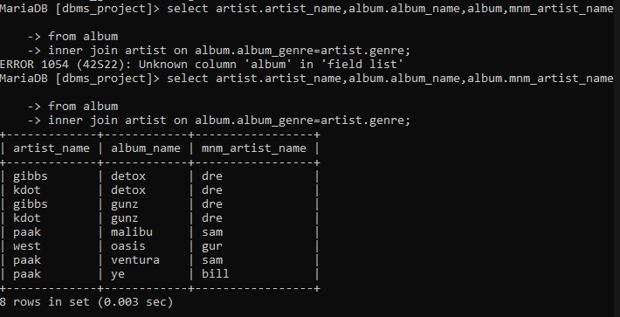

2)Show the distributor names of producers who are affiliated to the same music label and the format of music they exported in.

-> select distributor.distributor_name,distributor.format,producer.prod_name

-> from distributor

-> left join producer on distributor.label_name=producer.label_name;

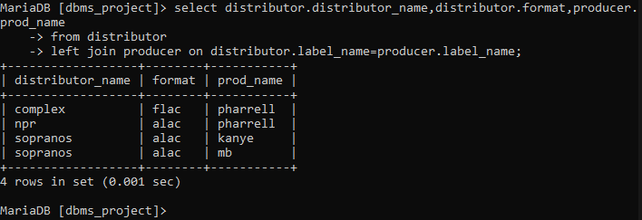

3)Showcase the artist-producer collaborations of the same label and the genre of the music they have worked on.

->select artist.artist_name,artist.genre,producer.prod_name

-> from artist

-> right join producer on artist.label_name=producer.label_name;

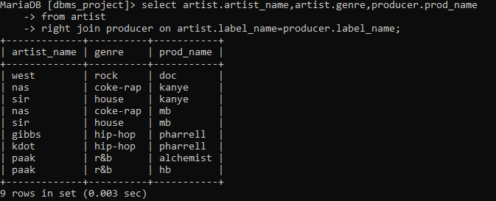

4)Show the songs and the album it is from, of an artist and the number of songs in the respective album.

->select song.song_name ,song.artist_name ,album.no_of_songs

-> from song

-> left join album on song.album_name=album.album_name;

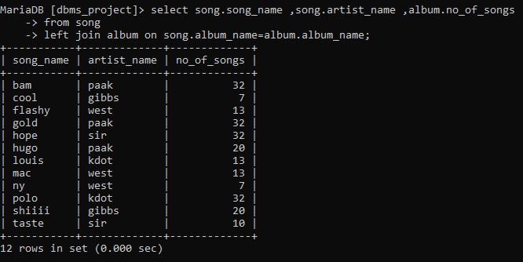

# AGGREGATE FUNCTIONS:

Show the number of songs with song length greater than 300 seconds

->select count(*)

-> from song

-> where song_length>300;

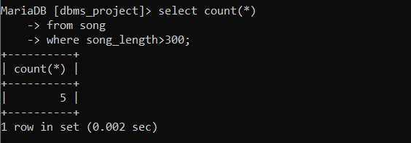

Show the total no_of_song’s length of the artist name west

MariaDB [dbms_project]> select sum(song_length)

-> from song

-> where artist_name='west';

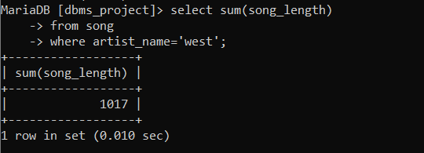

Show the average number of songs in an R&B genre album

->select avg(no_of_songs)

-> from album

-> where album_genre='r&b';

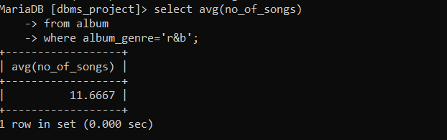

There are 12 songs, on an average ,for the R&B genre.

# SET OPERATIONS:

Show all the artist’s genres of the albums they have worked on

SELECT ALBUM_GENRE,artist_name FROM ALBUM

-> UNION

-> SELECT GENRE,artist_name from artists;

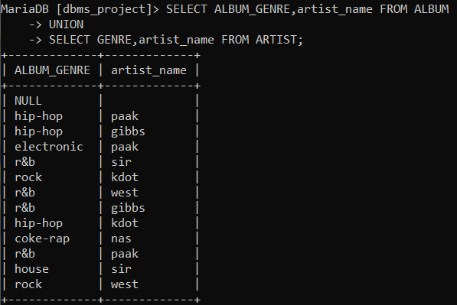

2) Show the common albums in Volume1(table name: album) and Volume2(Table name:album2)

select * from album

-> intersect

-> select * from album2;

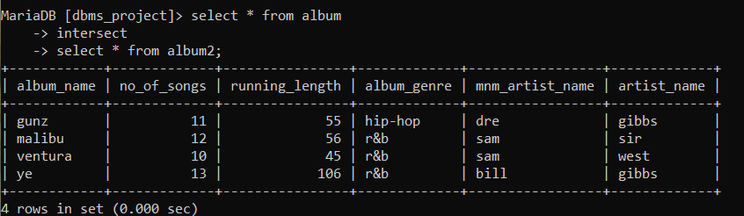

3)List out the albums that are in volume2 and volume1 wit the duplicates

MariaDB [dbms_project]> select * from album2

-> union all

-> select * from album;

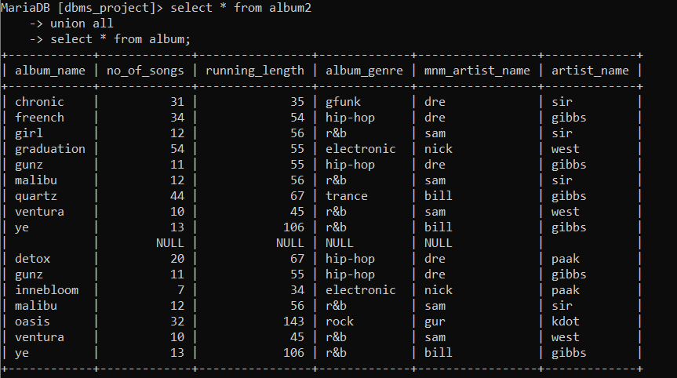

# STORED FUNCTION:

# Create a stored function for classifying a song as “short”,”medium” and “long”:

CREATE FUNCTION howlong(song_length int)

-> returns varchar(20)

-> DETERMINISTIC

-> BEGIN

-> DECLARE thislong VARCHAR(20);

-> IF SONG_LENGTH>300 THEN

-> SET thislong='long';

-> ELSEIF (song_length<=300 AND song_length>=200) THEN

-> SET thislong='medium';

-> elseif song_length<200 THEN

-> SET thislong='short';

-> END IF;

-> RETURN (thislong);

-> END$$

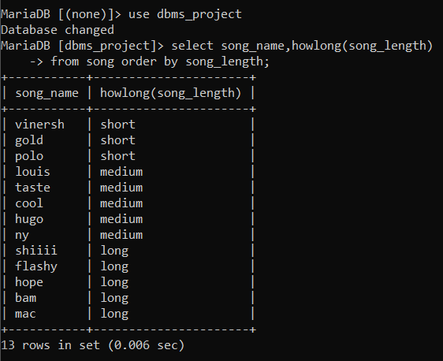

# STORED PROCEDURE:

Display the maximum number of songs in a volume of albums

DELIMITER &&

MariaDB [dbms_project]> CREATE PROCEDURE display_max_no_of_songs (OUT highsongs INT)

-> BEGIN

-> SELECT MAX(no_of_songs) INTO highsongs FROM album;

-> END &&

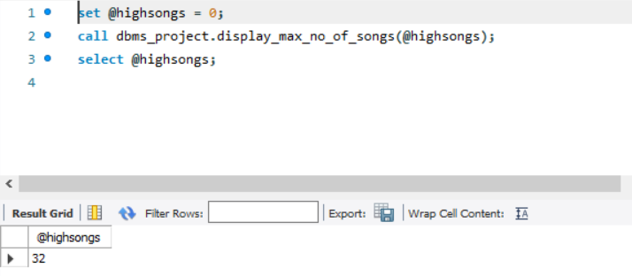

# TRIGGER

# Increment the number of songs field in album after a song has been added to the song table referencing to an album

DROP TRIGGER IF EXISTS `dbms_project`.`song_AFTER_INSERT`;

DELIMITER $$

USE `dbms_project`$$

CREATE DEFINER = CURRENT_USER TRIGGER `dbms_project`.`song_AFTER_INSERT` AFTER INSERT ON `song` FOR EACH ROW

BEGIN

update album

set no_of_songs=no_of_songs+1

where album_name=NEW.album_name;

END$$

DELIMITER ;

# SIMPLE FRONTEND IMPLEMENTATION

Streamlit has been used to display the various operations on the tables of the database

Provided below are the screenshots of the requirements of the project:

# Addition of a tuple:

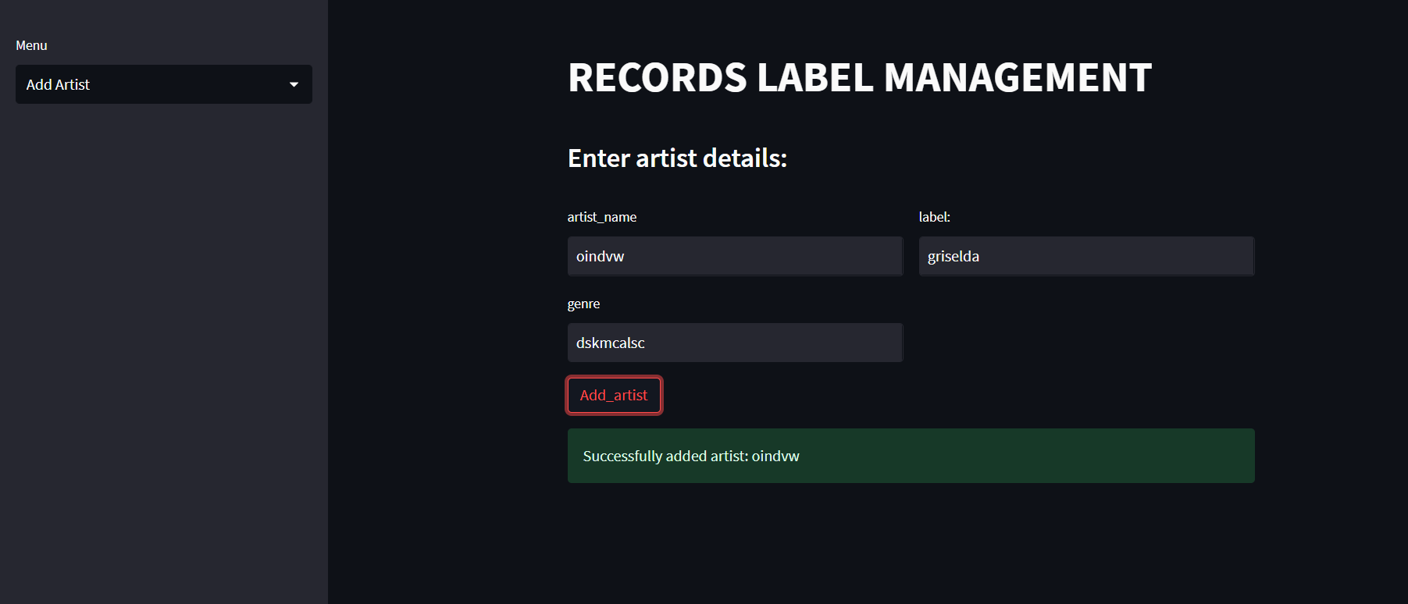

# Updation of a tuple :

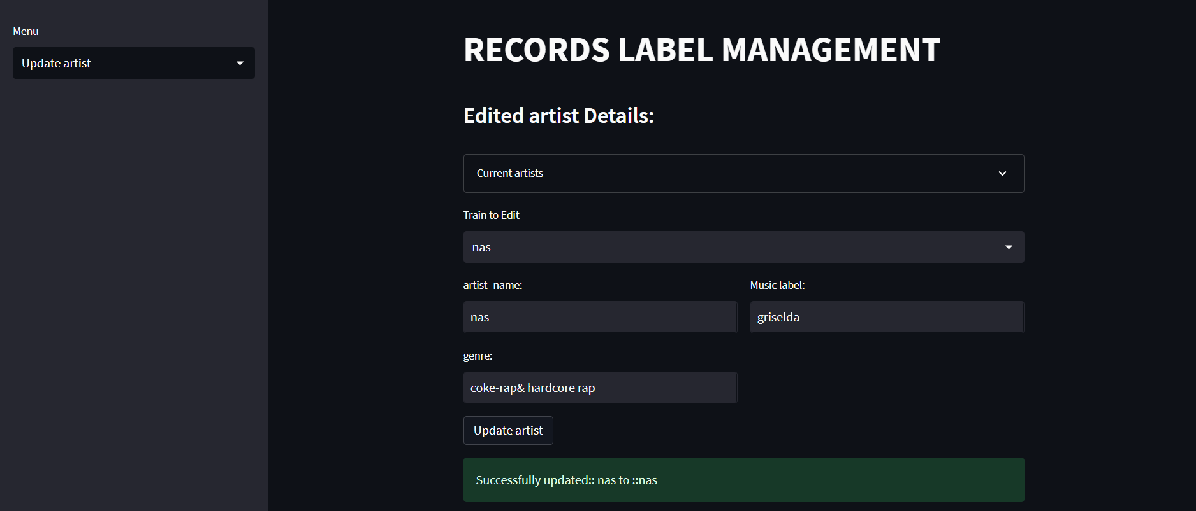

# Deletion of a tuple:

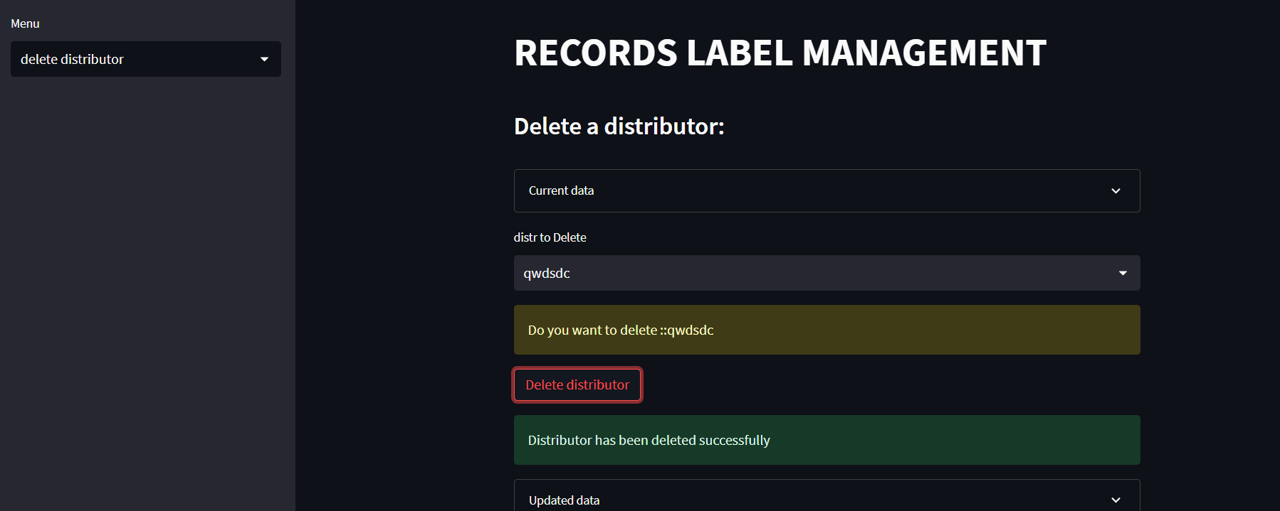

# Query runner:

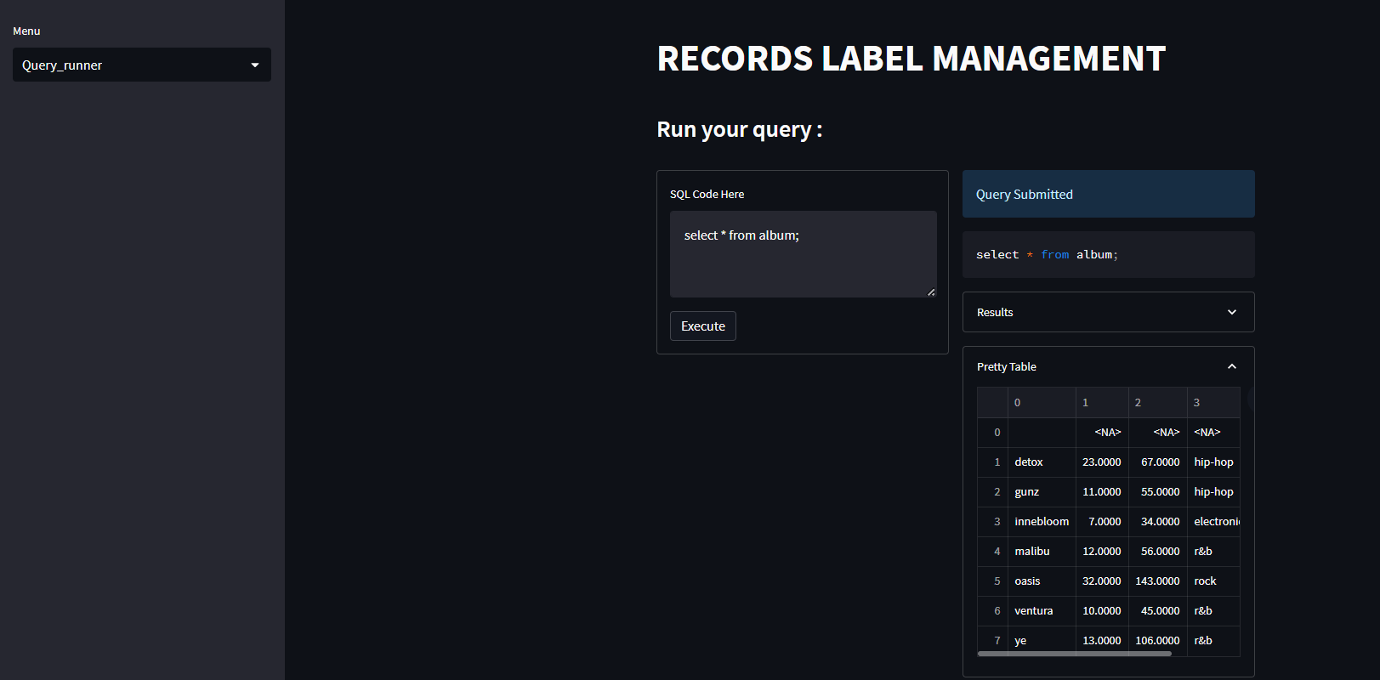

# MODIFICATION:

Create a stored procedure for showing the number of distributors an album has from the distributes table.

CREATE DEFINER=`root`@`localhost` PROCEDURE `distribute_no`()

BEGIN

select album_name, count(*) as num_distributors from distributes group by album_name;

END

